**Run The App**

Project Name: statistical machine learning TEAM ID: PNT2022TMID40553 approaches to liver disease prediction

**Run the application from anaconda prompt**

* Open new anaconda prompt from the start menu
* Navigate to the folder where your python script is.
* Now type “python app.py” command
* It will show the local host where your app is running on **http://127.0.0.1.8000/**
* Copy that local host URL and open that URL in the browser. It does navigate me to where you can view your web page.
* Enter the values, click on the predict button and see the result/prediction on the web page.

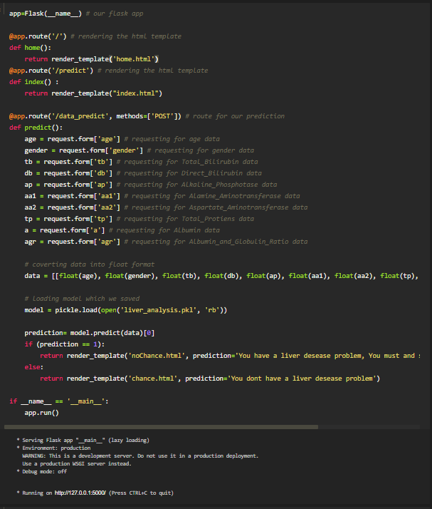

* Showcasing the output on UI

Home page is displayed when home button is clicked. Predict page is displayed when predict button is clicked. In predict page, enter input values to predict the liver disease or not. Finally, the prediction for the given input features is shown.

Home Page:

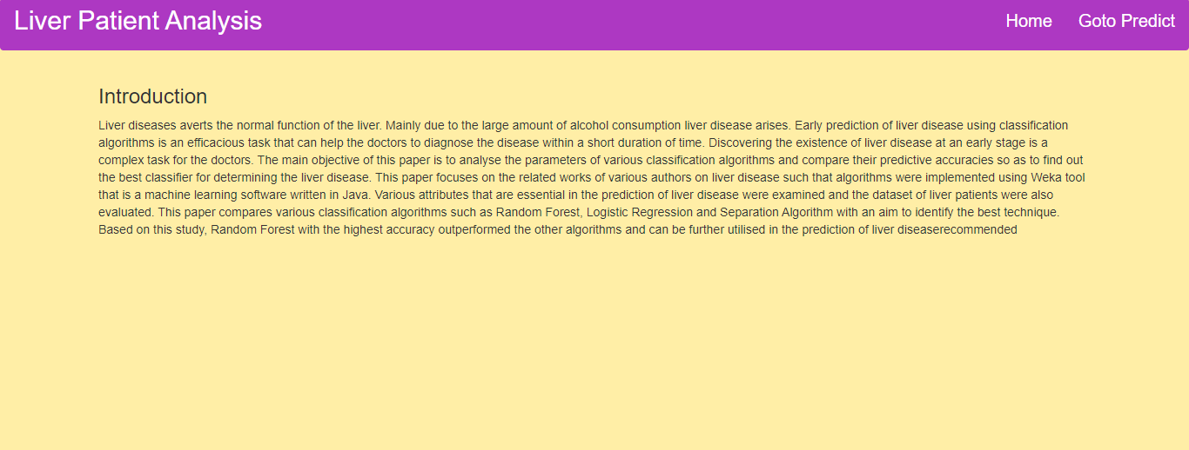

Prediction Page:

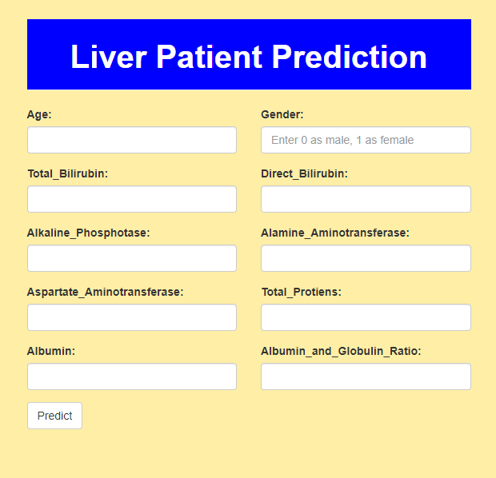

Output:

